Defect lifecycle: Defect life cycle is a cycle which a defect goes through during its lifetime. It starts when defect is found and ends when a defect is closed, after ensuring it’s not reproduced. Defect life cycle is related to the bug found during testing.

The bug has different states in the Life Cycle. The Life cycle of the bug can be shown diagrammatically as follows:

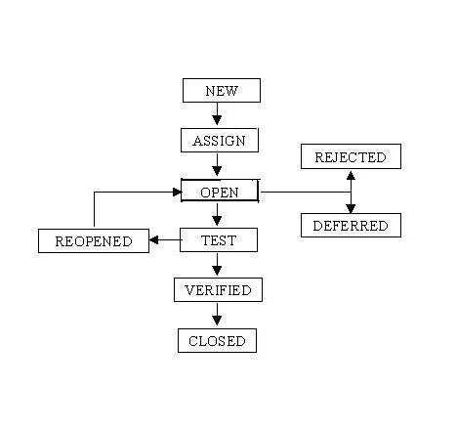

AGILE :it is a methodology, multi iterative lifecycle

product is brokeup into small pieces

agile ->sprint(day to day meeting)->scrum (stand up meeting )

SPRINT:

SCURM: each iteration is called as a sprint

In agile we write user stories

In agile the tasks are divided to time boxes (small time frames) to deliver specific features for a release.

Iterative approach is taken and working software build is delivered after each iteration. Each build is incremental in terms of features; the final build holds all the features required by the customer.

Here is a graphical illustration of the Agile Model:

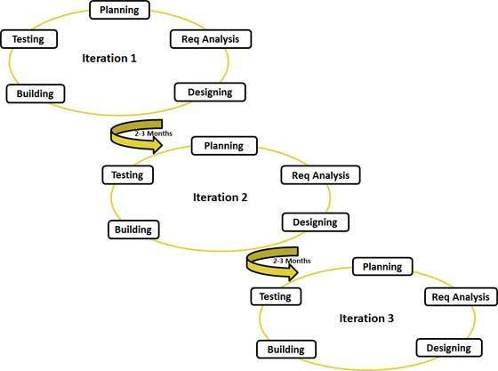

(Agile software development refers to a group of software development methodologies based on iterative development, where requirements and solutions evolve through collaboration between self-organizing cross-functional teams. Agile methods or Agile processes generally promote a disciplined project management process that encourages frequent inspection and adaptation.)

What are the different non functional testing?

Performance testing: load runner, Jmeter

Security testing

Load testing

Volume testing

Regression testing: it is type of testing one will perform the testing on already tested functionality again and again

It is usually done by the 2 scenories

Whenever the tester rasied the defects, it will be rectified by the developers then the next built is released to the test department to the test engineer then they will test the defected functionality as well as th related functionality once again

Whenever some new features are added by the developers then the next built is released to the test department to the test engineer then they will test related functionality of the new feature and they will check whether is working same as previous

User acceptance testing:is the level of testing in which one will perform the same system testing in the presence of the user in order to make him accept the application**.**

It has two testing alpha testing and beta testing

In alpha testing user acceptance testing will test the application in the company ,in presence of the customer

In this advantage if any defects are found then they is a chance of rectifying immediately

In beta testing user acceptance testing is done in presence of the client either by the end user or the third part before actual implementation

In this disadvantage is if any defects are found then they is no chance to rectify them immediately.

System testing:

Entire system is tested as per the requirements. Black-box type testing that is based on overall requirements specifications, covers all combined parts of a system

ADHOC Testing: - It is a type of testing in which one will perform testing on the application in style after understanding the requirements clearly.

What is unit testing?

Unit testing is called as a component testing

Unit testing can be done manual by often automatically

SDLC (Software development life cycle):

SDLC contains six phases

Initial phase or requirements phase ,Analysis phase, Design phase ,Coding Phase, Testing Phase and Delivery & Maintenance Phase.

## What is Test case?

A test case is a document, which has a set of test data, preconditions, expected results and post conditions, developed for a particular test scenario in order to verify compliance against a specific requirement.

Test Case acts as the starting point for the test execution, and after applying a set of input values, the application has a definitive outcome and leaves the system at some end point or also known as execution post condition.

## Typical test case parameter:

* Test Case ID
* Test Scenario
* Test Case Description
* Test Steps
* Prerequisite
* Test Data
* Expected Result
* Test Parameters
* Actual Result
* Environment Information
* Comments

Black box testing : If one performs testing only on the functional part of an application without having any structural knowledge then tat method of testing is known as Black-Box testing, usually the test engineers perform it.

White box testing : If one performs testing on the structural part of an application then that method of testing is known as white box testing, usually the developers or white box testers perform it.

What is sprint planning meeting?

In [Scrum](https://www.mountaingoatsoftware.com/agile/scrum), the sprint planning meeting is attended by the product owner, Scrum Master and the entire Scrum team. Outside stakeholders may attend by invitation of the team, although this is rare in most companies.

What is test case: A test case is a documentation which specifies input values, expected output and the preconditions for executing the test.

How to arise a defect and what we specify while logging defect?

A defect is logged during the test execution, when expected result and actual result don't match with each other.

Defect module in HP ALM not only helps users to post the defects but also enables them to track and gives the overall quality of the release at any stage of the development process.

What are the tools used to defect the management?

Hp ALM(application life cycle management )

Jira

Bugzilla

Rational clear quest

What is enter and exit criteria?

What is v model?

V- model means Verification and Validation model. Just like the waterfall model, the V-Shaped life cycle is a sequential path of execution of processes. Each phase must be completed before the next phase begins.  Testing of the product is planned in parallel with a corresponding phase of development in **V-model.**

Difference between load and performance testing ?

Performance Testing**:** Evaluates the overall performance of the system. Key elements are as follows:

Validate that the system meets the expected response time.  
 Evaluate that the significant elements of the application meets the desired response time.  
It can also be conducted as a pert of integration testing.  
It can also be conducted as a part of systems testing.

Load Testing**:** Evaluates whether the system’s performance is as expected under normal and expected conditions. Key points are

Validate that the system performs as expected when concurrent users access the application and gets the expected response time. This test is repeated with multiple users to get the response time and throughput.  
At the time of testing, the data base should be realistic. The test should be conducted on a dedicated server which stimulates the actual environment.

What is traceability matrix?

A traceability matrix is a document that co-relates any two-baseline documents that require a many-to-many relationship to check the completeness of the relationship. It is used to track the requirements and to check the current project requirements are met.

What is production environment

A Production environment is where the wave set application is actually available for business use.

### What is Priority and defect severity in defects?

Defect Priority states the order in which a defect should be fixed. Higher the priority the sooner the defect should be resolved.

Defects that leave the software system unusable are given higher priority over defects that cause a small functionality of the software to fail.

Defect severity In software testing, defect severity can be defined as the degree of impact a defect has on the development or operation of a component application being tested.

What tester will do in each phase of SDLC?

The Role of a Tester in SDLC  
Tester prepares the Test cases, Test Scenarios  from the SRS  
Using the script the tester performs different kinds of testing (Regression, Function)  
Tester Notes the results(pass/Fail)  
 If Result=Fail then the scenario is raised in the Test director   
Once its fixed by the developer the tester performs a regression testing

When do we use integration testing?

We normally do Integration testing after “Unit testing”.

Once all the individual units are created and tested, we start combining those “Unit Tested” modules and start doing the integrated testing. So the meaning of Integration testing is quite straight forward- Integrate/combine the unit tested module one by one and test the behavior as a combined unit.

The main function or goal of Integration testing is to test the interfaces between the units/modules.

What is STLC life cycle?

It consists of series of activities carried out methodologically to help certify your software product. These activities (stages) constitute the Software Testing Life Cycle (STLC).

[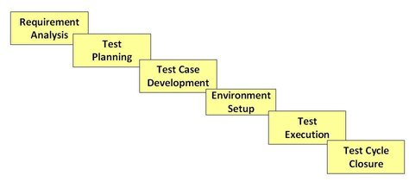](http://cdn.guru99.com/images/stories/software-test-life-cycle.jpg)

What is TDD and BDD (cucumber frame work)

### **Test Driven Development**

Test-driven development (TDD) is a software development process that relies on the repetition of a very short development cycle: first the developer writes an (initially failing) automated test case that defines a desired improvement or new function, then produces the minimum amount of code to pass that test, and finally the new code to acceptable standards.

### **Behavior Driven Development**

In software engineering, behavior-driven development (abbreviated BDD) is a software development process based on test-driven development (TDD). Behavior-driven development combines the general techniques and principles of TDD with ideas from domain-driven design and object-oriented analysis and design to provide software development and management teams with shared tools and a shared process to collaborate on software development.

Cucumber is a tool based on Behavior Driven Development (BDD) framework which is used to write acceptance tests for web application. It allows automation of functional validation in easily readable and understandable format (like plain English) to Business Analysts, Developers, Testers, etc.

what is burndown chart and velocity

Scrum Burndown Chart :

The Scrum Burndown Chart is a visual measurement tool that shows the completed work per day against the projected rate of completion for the current project release. Its purpose is to enable that the project is on the track to deliver the expected solution within the desired schedule.

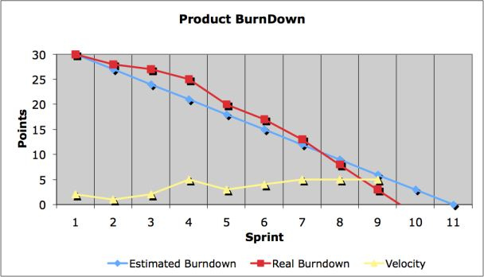

Velocity :

The rate of progress of a Scrum Team is called "velocity". It expresses the amount of e.g. story points completed per iteration. An import rule for calculating the velocity is that only stories that are completed at the end of the iteration are counted.

## What is Acceptance Testing?

Acceptance testing, a testing technique performed to determine whether or not the software system has met the requirement specifications. The main purpose of this test is to evaluate the system's compliance with the business requirements and verify if it is has met the required criteria for delivery to end users.

Entry and exit criteria

Entry criterion is used to determine when a given test activity should start. It also includes the beginning of a level of testing, when test design or when test execution is ready to start.

Exit criterion is used to determine whether a given test activity has been completed or NOT. Exit criteria can be defined for all of the test activities right from planning, specification and execution.

Exit criterion should be part of test plan and decided in the planning stage.

what is waterfall in SDLC?

In "The Waterfall" approach, the whole process of software development is divided into separate phases. In Waterfall model, typically, the outcome of one phase acts as the input for the next phase sequentially.

Following is a diagrammatic representation of different phases of waterfall model.

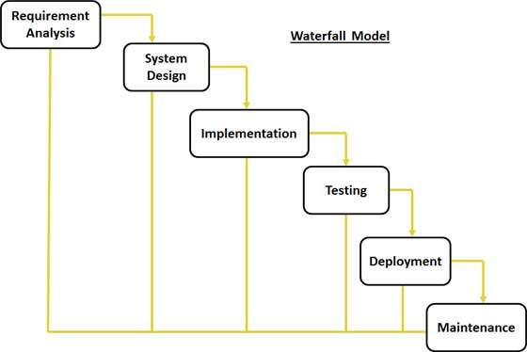

1. **types of test metrics we use normally**

In software testing, **Metric** is a quantitative measure of the degree to which a **system, system component, or process**possesses a given attribute.

In other words, metrics helps estimating the progress, quality and health of a software testing effort. The ideal example to understand metrics would be a weekly mileage of a car compared to its ideal mileage recommended by the manufacturer.

**Type of metrics**

**Base Metrics (Direct Measure)**   
  
Base metrics constitute the raw data gathered by a Test Analyst throughout the testing effort. These metrics are used to provide project status reports to the Test Lead and Project Manager; they also feed into the formulas used to derive Calculated Metrics.   
Ex: # of Test Cases, # of Test Cases Executed   
  
Calculated Metrics (Indirect Measure)   
  
Calculated Metrics convert the Base Metrics data into more useful information. These types of metrics are generally the responsibility of the Test Lead and can be tracked at many different levels (by module, tester, or project).   
Ex: % Complete, % Test Coverage   
  
  
Base Metrics & Test Phases

* • # of Test Cases (Test Development Phase)
* • # of Test Cases Executed (Test Execution Phase)
* • # of Test Cases Passed (Test Execution Phase)

of Test Cases Failed (Test Execution Phase)

* • # of Test Cases Under Investigation (Test Development Phase)
* • # of Test Cases Blocked (Test dev/execution Phase)
* • # of Test Cases Re-executed (Regression Phase)
* • # of First Run Failures (Test Execution Phase)
* • Total Executions (Test Reporting Phase)
* • Total Passes (Test Reporting Phase)
* • Total Failures (Test Reporting Phase)
* • Test Case Execution Time ((Test Reporting Phase)
* • Test Execution Time (Test Reporting Phase

Calculated Metrics & Phases   
The below metrics are created at Test Reporting Phase or Post test Analysis phase 

* • % Complete
* • % Defects Corrected
* • % Test Coverage
* • % Rework
* • % Test Cases Passed
* • % Test Effectiveness
* • % Test Cases Blocked
* • % Test Efficiency
* • 1st Run Fail Rate
* • Defect Discovery Rate
* • Overall Fail Rate